|  |  |
| --- | --- |
| spider | C:\Documents and Settings\barnesc\Local Settings\Temporary Internet Files\Content.IE5\9CUZB3WQ\MC900133409[1].wmf  **Capitalize:** Hold Shift button and tap letter.  **.**  Choose Period**.**  **Erase**: Put cursor behind letter and tap delete.  **Space**: Tap long spacebar.  **New line**: Tap Return key. |
| ghost | C:\Documents and Settings\barnesc\Local Settings\Temporary Internet Files\Content.IE5\3FYNMTPK\MC900436213[1].png |
| witch | C:\Documents and Settings\barnesc\Local Settings\Temporary Internet Files\Content.IE5\3FYNMTPK\MC900436109[1].wmf |
| pumpkin | C:\Documents and Settings\barnesc\Local Settings\Temporary Internet Files\Content.IE5\C0ZIZRJE\MC900305493[1].wmf |

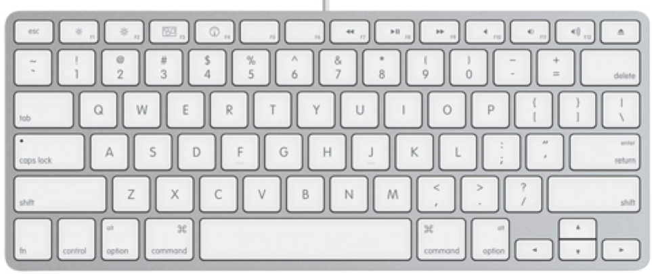

☺ I see a spider.

☺ I see a

☺

☺

Name: