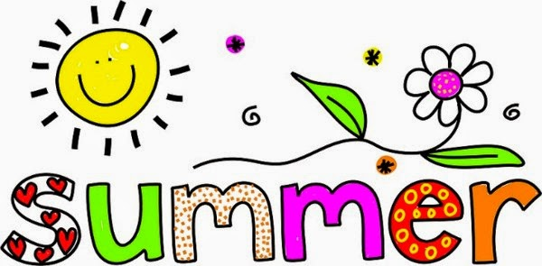
Using ABCYa Story Creator, write and illustrate your summer vacation. Below are some ideas to get you started:

- What are some of the places you visited?
- What are some of the people you met?
- What are some of the activities you participated in?
- What new adventure did you have?
- Did you learn any new and interesting things?
- What are some feelings about summer vacation?
- What would you like to do during summer vacation next year?

